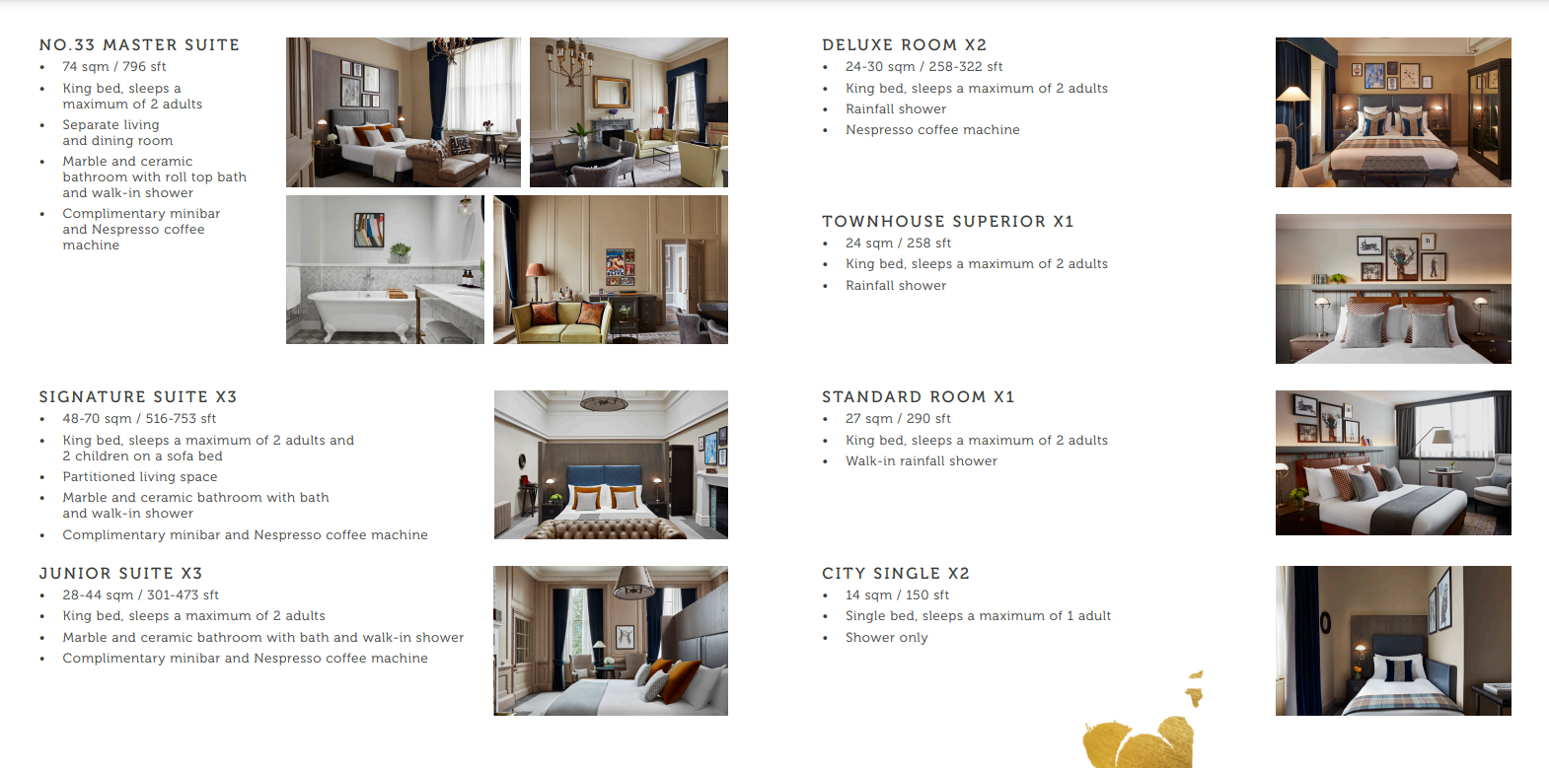
Number 33 at Kimpton Charlotte Square

